CHAPTER 13
Mechanical Properties of Materials
Introduction
This chapter is on the mechanical properties of materials. Here Archie is on fairly safe ground, as he lectured a course on Materials for Engineers to Cambridge undergraduates for several years in the 80’s and 90’s. However, the material is taken primarily from the pioneering work of Ashby and Jones (1) who realised some time ago that what Engineers needed was not that provided by Physicists, nor that provided Materials Scientists, but something much more tailored. In particular, Engineers need more than a mere list of mechanical properties contained in a data book, but do not need the amount of microscopic detail presented characteristically in physics and materials courses. Engineers want a structure that makes approximate sense of the wide range of material properties, and an explanation of the major catastrophes that have occurred historically to inform technical decision-making processes moving forward.
Failures can be expected as engineers move into unchartered territory. Two well-known examples capture this. The Tacoma Narrows Bridge, a pioneering design of suspension bridge, in 1940 shook itself to pieces in a light breeze. And the De Havilland Comet aircraft had square windows and fatigue failure caused by stress concentration near the window corners caused the explosion of BOAC flight 781 in 1954. Understanding how materials behave is at the heart of an engineer’s toolbox.
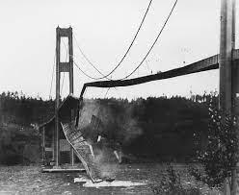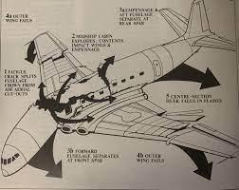
(a) (b)
Figure 1. Well-known engineering failures. (a) The Tacoma Narrows Bridge and (b) the De Havilland Comet aircraft. OUP: NOT SURE WHERE THIS IMAGE IS FROM

Elastic Properties of Materials

1. Material Properties
A main objective of engineers is to prevent a broad range of devices changing their shape by too much during operation. Distortion is determined fundamentally by the mechanical properties of the device and the structure fails if any one of the large number of possible properties is inadequate. The three most fundamental ways of failing, with their material parameters, are:

Mechanism Colloquial Measurable Parameter
Elastic Stiffness Elastic Modulus
Plastic (or Yield) Hardness Yield stress
Fracture Brittleness Fracture Toughness

Each mechanism has a colloquial term and a measurable, scientific parameter. None involve the word ‘strength’, which should only be used if it is the deliberate intention to be vague. In particular, the ‘tensile strength’ is only used as a comparison between ductile materials in tension where the yield stress is ill-defined. It is not a useful design parameter. Saying that ‘spiders web is stronger than steel’ is meaningless unless all the parameters are specified. Spectacular claims are usually obtained by dividing a failure stress by the density, which, effectively, is cheating. Often people use the words “strong” and “stiff” interchangeably, but to engineers they have very different meanings.

2. Elastic Deformation
The elastic constants describe the stress in a material for small strains. Since the stress and strain at a point in a material have nine components, in principle there are eighty-one constants relating them. However, this large number is reduced significantly by symmetry considerations to three independent constants for cubic single crystals, and two for an isotropic polycrystal. A theoretical connection between the single crystal moduli and those for an isotropic polycrystal of the same material cannot be made with any accuracy, so the moduli must be measured experimentally. Even Landau and Lifshitz were unable to make this link.

2.1 Poisson’s Ratio
The two basic moduli used are normally Poisson’s ratio ν, (lateral/longitudinal strain), and E, Young’s modulus for tension, which is the most useful. A simple illustration is the 2D mechanical structure in Fig. 2, where we assume the bars all have the same modulus of elasticity.
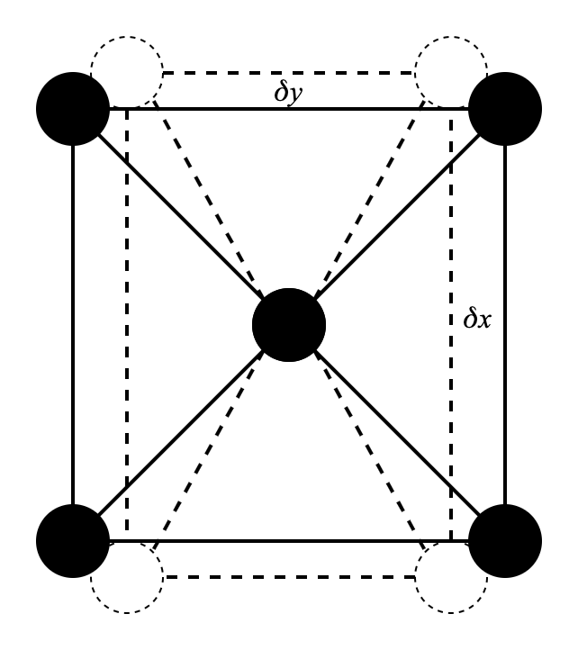
Figure 2. A structure with Poisson’s ratio 1/2√2.

The square in Fig. 2 is of side 2a and we distort it by moving each corner by δx and δy as shown (δx is negative in this case). The increase in half length of the diagonal is (δx+δy)/√2. The strain is (δx+δy)/2a so, if the x component of the elastic stress due to this is to balance that in strut along the x-axis, then δx = (δx+δy)/2√2. Hence Poisson’s ratio, ν = −δx/δy = 1/3.8. This is a satisfying result because most crystalline solids have a ratio of close to 1/3.

One exception is rubber. This consists of long molecular chains that can be stretched-out, but there are no gaps between them so the volume is nearly constant and Poisson’s ratio is therefore roughly ½. You can see this when you stretch a rubber band – it gets visibly thinner as you stretch it. The compression modulus of rubber is very high compared with its other moduli (about a quarter that of lead). This is relevant to the sealing of rubber ‘O’ rings, such as those in the Challenger disaster described below.

Although the bulk modulus of rubber is due to interatomic forces, Young’s modulus and the shear modulus are determined by quite a different mechanism. The long polymer chains have relatively few cross links so that, at room temperature, they can lash about like eels in a fishing net. The higher the temperature the more they lash about and the more difficult it is to straighten them. The modulus increases with temperature so that a piece of rubber cools when stretched. The thermodynamics is similar to that of a gas.

Another exception is cork, which has a columnar structure such as that shown Fig. 2, but without the diagonal bars. In this case Poisson’s ratio is nearly zero. This means it can be pushed into the neck of a bottle and seal it. A normal material expands sideways if you push it. A rubber cork would be hard to push into a bottle because it would squeeze out sideways and you wouldn’t get it in. And then if you did then when you release the pressure on the cork it would come loose in the bottle. Even better for this application would be a material with a negative ratio as these would expand into the neck on releasing the pressure. This can be achieved with artificial structures.

2.2 Young’s Modulus
This is determined by the force between atoms when we move them. Since, in equilibrium, the atoms are in a potential minimum, the force is linear for small strains. A crude estimate can be obtained by saying that if we double the bond length in tension (strain = 1) the energy needed per atom is about the bond energy U_{o}. Hence 0.5E = U_{o}/a³. For U_{o} = 1 eV and a = 0.1 nm this gives E = 320 GPa, which can be compared with that of tungsten (345 GPa).

We can explain many of the properties of materials, at least qualitatively, with the power law relation, which is illustrated in Fig. 3. We assume the energy between two atoms can be represented by:

For an ionic solid, the electrostatic force means m is 2 and for other forces it will be a little larger. The coefficient n is the response to pushing atoms together which is a strong resistance, and typically n is about nine (it can be measured by exerting extreme hydrostatic pressures).

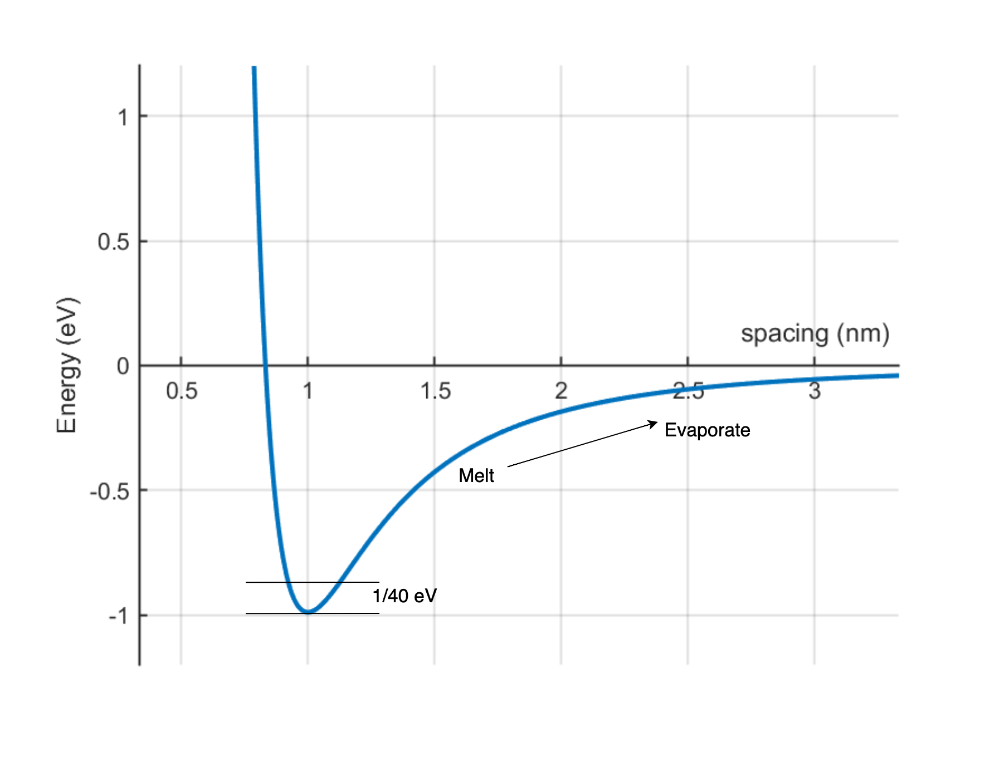
Figure 3. The variation of energy of an atom with distance from its neighbour (spacing) for n = 9 m = 3. Thermal activation causes vibration, sufficient vibration causes melting and then evaporation. HUGH DID THIS IN MATLAB

U_{o} and the atomic spacing are known from basic physics. We can add to this diagram the movement due to thermal activation (1/40 eV at room temperature, 300 K), and the melting point at the Lindemann criterion of an rms amplitude of 10% of the of the atomic spacing. It should be said that melting is a very obscure effect and is very difficult to explain in simple terms (or even complicated ones). We can easily understand the solid and the vapour, but the sudden collapse of the shear modulus to zero at a very precise temperature is still something of a mystery.

The energy can be rewritten in terms of the binding energy U_{o,} and the atomic spacing a and then expanded to order x³ for small extensions x from the equilibrium position.

₍₁₎

Here an external force f has been added. We can use this equation to calculate a wide range of properties. The object is not to obtain accurate values, but to show the qualitative relation between properties and their relation to the binding energy of the atoms. This gives structure to what is otherwise just a very large data base of material properties, which is very useful for a design engineer. It also distinguishes between those properties for which the procedure could be made more accurate, which are structure independent, and those that depend on defects, such as the yield stress or fracture toughness. These require different physics. For consistency we will assume a binding energy of 1 eV, an atomic spacing of 1 nm and a simple cubic structure. We assume n = 9 and m = 3.

2.3 Elastic Modulus
The restoring force at 0 K (x ~ 0) is f = nmx/U_{o}a² so if the atoms are in a cubic array ε = x/a and σ = f/a². Hence, E = nmU_{o}/a³ which is 4000 GPa. This is about ten times that of tungsten and is a bit large, but the principle is valid.

At higher temperatures the modulus is the average of dU/dx for finite amplitudes x.

₍₂₎
Assuming x averages to zero, the first term is the zero temperature modulus and the second is about 0.7 if x is 0.1a at the melting point. Thus, we expect the modulus to be reduced by a factor of about 0.3 between absolute zero and the melting point. (It is usually about a factor of 2).

2.4 Coefficient Thermal of Expansion
The coefficient of thermal expansion is obtained from the cubed term in the expansion with f = 0, the x squared term gives no mean displacement. To a first approximation, if U = −U_{o}+kT, the amplitude of oscillation is:

Now put x = x_{o} + δ in (2). Then:

This is positive to the right and negative to the left, so there is a net expansion of δ. If U_{o} is 1ev, and at 300 K, kT is 1/40 eV then the expansion coefficient is 15x10⁻⁶ K⁻¹ and independent of temperature. This is about the value for iron.

2.5 Relation between Moduli.
As pointed out above, there are only two independent moduli but it is straightforward to use ν and E to derive the others.

Consider a unit cube of material and first apply σ_{x} to the x faces. This produces a strain ε_{x} = σ_{x}/E . Now apply σ_{y} [Fig. 4(a)] which adds an x strain of –νσ_{y}/E. Now add σ_{z} to the 3rd face so that the total x strain is

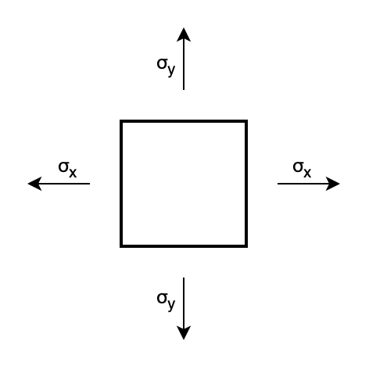 | 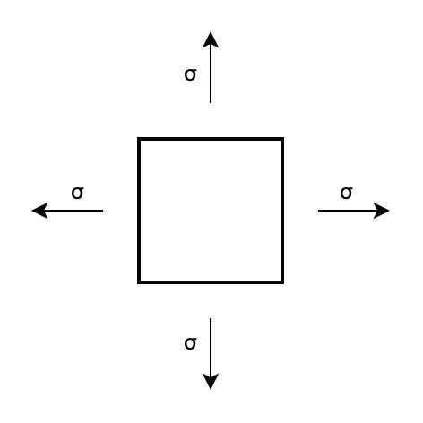
(a) | (b)
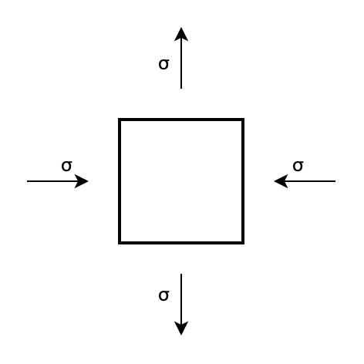 | 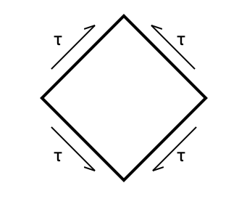
(c) | (d)

Figure 4 (a) Stresses on a unit cube (z perpendicular to the page). (b) hydrostatic stress occurs when the stresses on all faces are equal. (c) and (d) pure shear with σ_{z} = 0.

There are similar equations for the other components, from which the bulk and shear moduli can be calculated. For the bulk modulus [hydrostatic stress Fig. 4(b)], all the stresses and strains are the same so σ _{x}= σ _{y}= σ_{z} = –p and the change in volume δV = –3ε_{x}. Hence, K = E/[3(1-2ν)]. For pure shear Fig. 3c, –σ_{x} = σ_{y} = τ and σ_{z} = 0. The shear strain γ = –2ε_{x} = 2ε_{y}. Hence the shear modulus G = E/[2(1+ν)].

K is close to E while G = 3E/ f for ν = 1/3, which is a good approximation for most engineering materials. As pointed out above, the exception is rubber, which has a value ν close to 0.5 so that G = E/3 and the bulk modulus is much larger than either. Rubber is effectively incompressible under hydrostatic conditions.

3. Elastic Failures
Elastic failures are rare since elasticity is well understood and the mathematics relatively easy to simulate using a computer. They usually involve more than simple elasticity. The simplest is when a beam or sheet buckles under compression. The buckling load for a simple rod under compression was calculated by Euler in 1757. Fig. 5 shows a rod bending under compression.

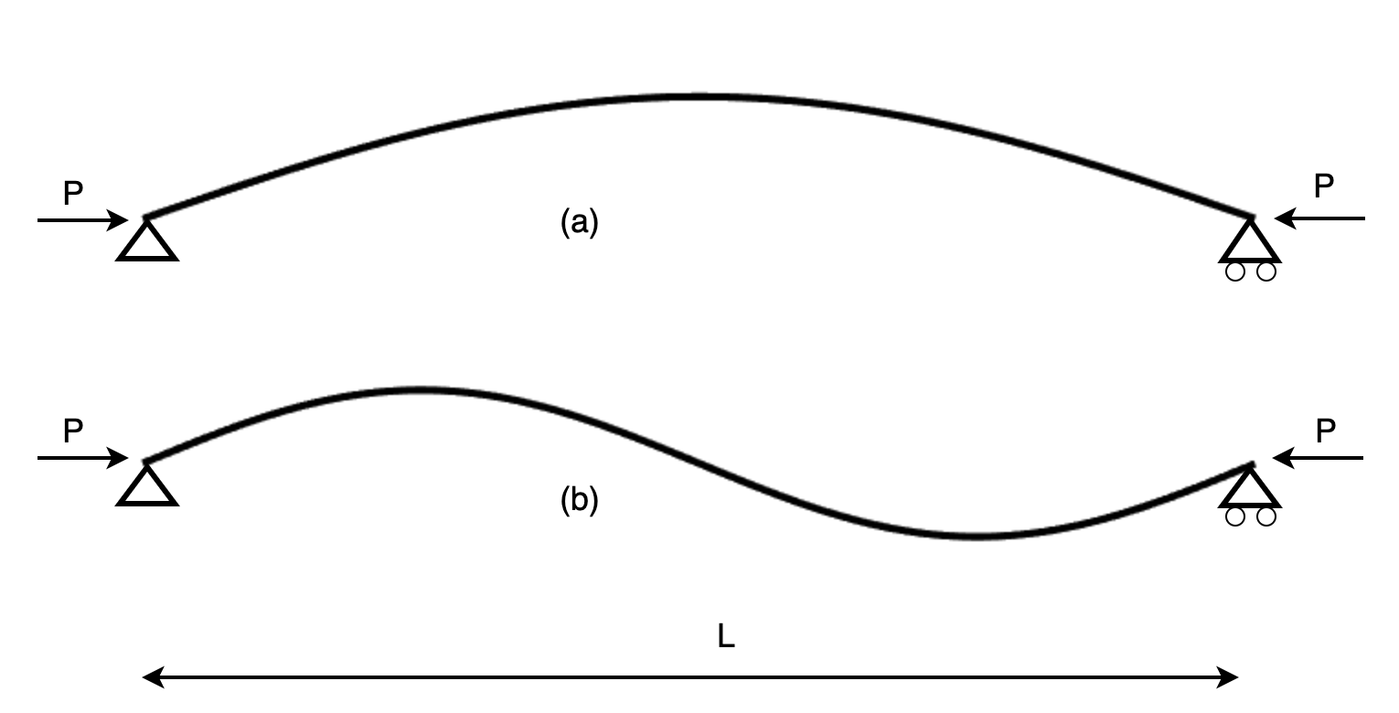

Figure 5. A rod of length L subject to an axial force, P. (a) The principal buckling mode P = (π² E I) / L²
and (b) the second mode P = (4π² E I) / L². E is the Young’s modulus of the rod and I is its second moment of area.

For a bent beam, a bending moment M produces a curvature M/EI, where E is Young’s modulus and I the second moment of area, 0.25πr⁴ for a solid cylinder of radius r. For a small bending radius, the moment is P y so:
$Py=EI$$\frac{{}^{2}}{d{}^{2}}$

The solution is a sine and, if the ends can rotate but not move, the length must be half a wavelength [Fig. 5(a)].

Hence:
$P=$$\frac{{}^{2}}{{}^{2}}$

Other solutions exist, for example the second mode shown in Fig 5(b). Note that the amplitude of the deflection is arbitrary, at least for small amplitudes. This means that we have a neutral or unstable equilibrium. For an infinitesimal reduction in force, the solution does not apply and the rod straightens out. For an infinitesimal increase, the amplitude increases until limited by non-linear effects.
As a result, buildings can be very tall without buckling. A similar calculation for a uniform vertical circular pillar or radius r under gravity leads to a Bessel equation. The critical height is:

where E is the Young’s modulus and ρ is the density of the material. For a limestone pillar 1m in diameter this is 124 m, about the height of the Big Ben clock tower.

One of the most famous failures is the collapse of the Tacoma Narrows suspension bridge. This was built before computers could simulate a complete bridge in cross winds and followed the pattern of mediaeval cathedral builders, which was to push the limits until one fell-down (in their case Beauvais). The Tacoma Narrows bridge was too thin and in a strong cross wind built-up a resonance that led to it undulate like a slinky spring until it fell into the sea. Fortunately, this took a few hours and motorists were able to move off in time.

A more tragic example was a miscalculation (or rather no calculation) of the maximum strain at which a bungee rope could take. When a rubber is stretched sufficiently, the polymer chains are completely aligned and the modulus is determined by that of the covalent carbon bonds in the chains, which is very high. When this occurred for a bungee jumper who was a bit heavier than his predecessors, his fall was stopped so suddenly the straps on his feet were jerked off and he fell to his death. A simple calculation of the maximum energy per unit volume the rubber could store before reaching the limit of the chain, compared with the kinetic energy of the customer, would have avoided this tragedy. The same works for climbing ropes, as in Fig 6. Were the climber to fall then the rope AB would need to stretch by an amount x and absorb the potential energy of a fall from height 2L+x. Typically a climbing rope will stretch about 20% of its length before it breaks.

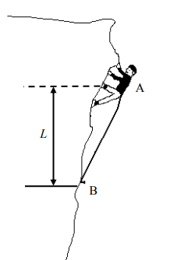
Figure 6. A climber on a rope AB, anchored at B. The stretch of the rope x needs to be enough so as to avoid a sudden jolt that will injure the climber but not so much as to break the rope. OUP: THIS IS FROM CUED PREPARATORY PROBLEMS FOR NEW STUDENTS. I'M SURE WE CAN GET PERMISSION TO USE IT

3.1. The Challenger Disaster
In 1986 the Challenger spacecraft exploded shortly after launch, killing all on board (Fig. 7). The cause was a failure of the ‘O’ rings’ sealing two sections of the first stage solid rocket, which allowed hot gases to escape sideways and ignite a liquid fuel tank. The Rogers committee of enquiry included Richard Feynman, who famously demonstrated that the ‘O’ rings would lose ‘resilience’ in the cold weather which had occurred at the launch pad.
In fact, it had been known for years that there was a major problem with this joint, but this was not transmitted to the NASA management, who, in any case, seem to have had a poor understanding of safety analysis. When some earlier ‘O’ rings had burned a third of the way through they claimed that this showed there was a safety factor of three! Fig. 6b shows a diagram of the relevant parts of the joint. The combustion chamber is on the right and the route to the ‘O’ rings is through a tube plugged with heat resistant putty that flows under pressure. Given the stress and vibration from a rocket, it looks like a pretty flimsy joint and so, unfortunately, it proved. An excellent account is in the fourth edition of Ashby and Jones (1) on which much of this analysis is based.
The design was supposed to ensure that the pressure in the combustion chamber would tend to increase the pressure on the seal. In practice the reverse happened. It was called ‘joint rotation’. The joint section was much thicker than the cylinders of the combustion chamber so that when the rocket pressure caused the radius of the cylinders to expand, the joint expanded much less. This meant that the top of the joint was bent anticlockwise and the bottom one clockwise, thus opening-up a gap between the ‘O’ rings and the outer cylinder, which then led to the leakage of hot gases.

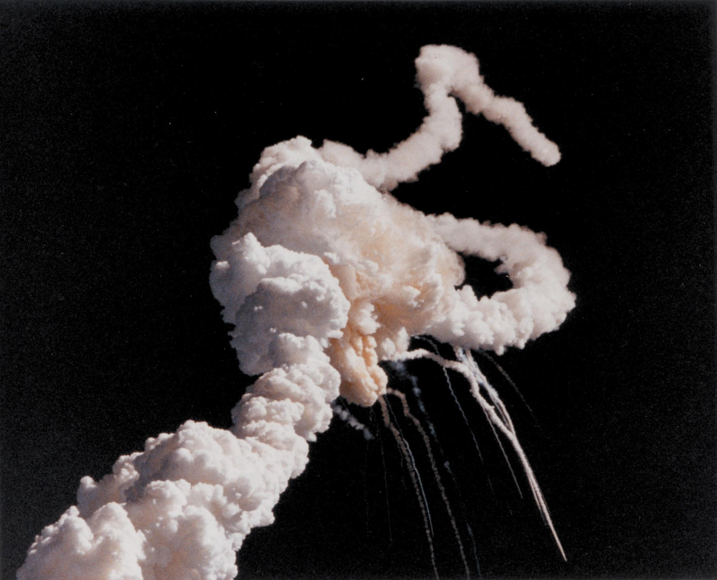 | 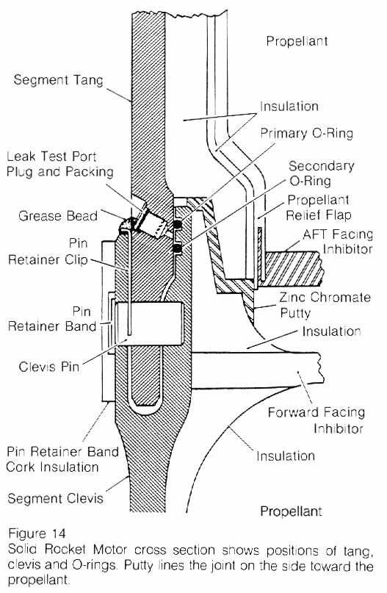
(a) | (b)

Figure 7. The Challenger disaster. (a) The aftermath of the explosion and (b) the join and ‘O’ ring seal. OUP: NOT SURE WHERE THESE COME FROM

During testing, the ‘O’ ring resealed the gap quite quickly. This was unfortunate because it led the engineers to believe that the joint was good, ignoring the possibility of failure of the joint, the pass-by of hot gases and the burning of the ‘O’ rings.

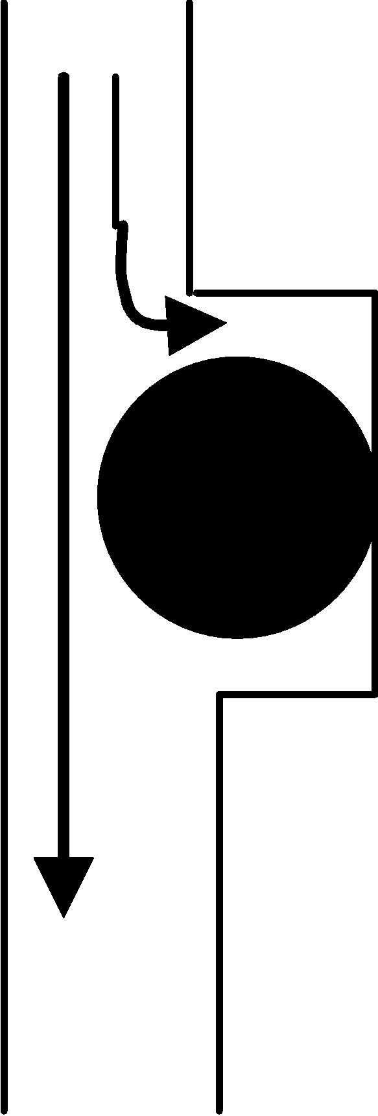 | 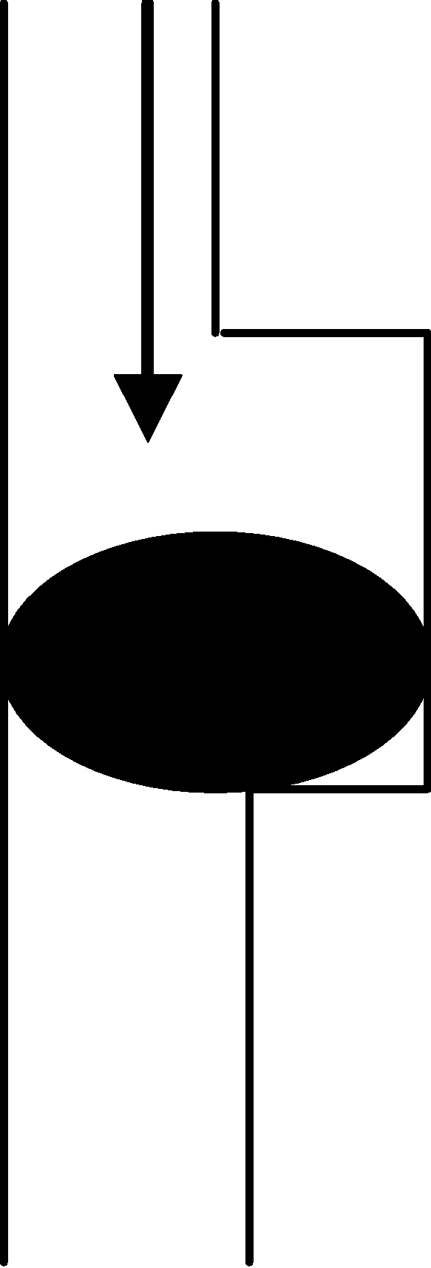
(a) | (b)

Figure 8. The ‘O’ ring seal, (a) the gap widens to allow initial blow past the gap, (b) Higher pressure squashes the ‘O’ ring to recreate the seal. Unfortunately, the cold temperature on the day meant the ‘O’ ring was more like glass than rubber.
Figure 8 shows the behaviour of an ‘O’ ring as the gap widens. The slots in an ‘O’ ring seal are larger than the ‘O’ ring itself, so that when the two plane surfaces are in contact there is room for the ring to spread sideways. (The bulk modulus of rubber is high so that the volume is nearly constant). When the gap opens exhaust gases shoot through. They are at the highest pressure at the top of the ‘O’ ring, and lower at the side, due to the Bernoulli effect, and at the bottom, which is nearer the exit to atmosphere. The result is that the ring is sucked back into the now much larger gap between the two parts of the rocket chamber and then forced to seal the gap by the pressure above. However, to seal the gap this must happen quickly, and before the ring has been damaged too much by the hot gases. The second O-ring is in much the same position so does not provide a very effective back-up seal. The pressure rises in about half a second, so this is the sort of time scale in question. The balance between resealing and disaster is obviously a fine one, but, although the problems were recognized, the risk of failure was considered ‘acceptable’. As Feynman pointed out, the company’s idea of how to calculate the risk of failure of the whole rocket system was completely invalid. It is hard to believe any engineer would take it seriously when they had seen evidence of burning of the ‘O’ ring by white hot gases, which according to the design, to which the ‘O’ rings should never have been exposed.
The temperature on the day of the tragedy was about –2 ºC, which was the coldest it had been, and well below the temperature at which the seal had been tested in operation. The statement by the company that the material was good to –40 °C, which is probably the glass temperature, would have been based on static tensile tests. However, like all glass melting the glass transition in rubber takes place continuously over a wide range of temperature. On cooling, the viscosity increases from a very low value to a very high value, until, at the glass temperature, the rubber is effectively extremely rigid even for static tests. (The brittleness follows from this as cracks are no longer blunted by elastic deformation at the root, but this is of no relevance to the Challenger disaster). At intermediate temperatures, the rubber will have a high modulus for sudden changes, and gradually relax to the low modulus state, just like ‘bouncing putty’. The viscosity is determined by the activation energy of the Van der Waals bonds between the polymer chains This is about 0.5 eV, so the time constant will double for every 5 ° C drop in temperature. The time taken to reseal was increased significantly by the low temperature when the launch was approved by NASA administrators, although the earlier burning of the rubber showed that there was little margin of safety. Feynman was able to show the slowed response of the rubber to the committee using his iced drinking water. He was so disturbed by the failures of NASA that he insisted on adding a minority report to the Rogers report pointing them out.

One puzzle that remains is that a jet of smoke was seen on launching, but failure did not occur until some minutes later. One explanation offered for this is that alumina from the exhaust resealed the joint temporarily. However, another possibility is that it resealed due to movement of the ‘O’ rings as before, but, on this occasion, they had been too badly damaged to last.

4. Case Study the Bow (and Arrow)
The Bow and arrow is perhaps the first piece of real technology invented by man and it has proved extremely effective in killing animals and people over the centuries. Its design makes an interesting case study as it is a relatively simple elastic device.

We need to start with the energetics, given that conservation of energy is the most fundamental law of physics. A man drawing a bow might produce a force of about 60 pounds or 267 Newtons. The arm can move about three feet (about 1 metre) to stretch the bow, so the energy available (force x distance) is 267 joules. (In mediaeval times the yard was defined as the distance from the King’s nose to his outstretched finger-tips and grains of wheat were a weight standard). This will propel a 300 grain (20 gm) arrow at a velocity of 110 m/sec, which is satisfactory (in terms of killing somebody). To make an effective bow, we need the wood to be able store this amount of energy. The mechanical properties of wood are complex with considerably lower strength in compression than in tension. Since the inside surface of the bow is in compression, the stress here limits the stored energy. The favoured wood is yew whose heartwood has a high compressive yield strength. The bow was cut so that the centre line of the bow came at the junction between the outer wood and heartwood to take advantage of the respective difference in strengths in compression (inner arc of the bow) and tension (outer arc of the bow). An aside is that the yew trees were grown in churchyards since their leaves are poisonous to cattle! In spite of the differences in properties, both woods could store about 0.6MPa/m³. Hence the minimum volume of wood needed was 191 cm³. However, we need firstly to allow for the variation in stress across the diameter of the bow since the stress along the centreline is zero. The stored energy is a factor of three less than that for a uniform stress for a round cross section. Secondly, if we assume that the force on the bow string rises linearly with displacement, then only half the maximum energy of the archer is available since he (in this case) is not pulling at his maximum force the whole way. This increases the volume needed by a factor of six to 1144 cm³.

If a longbow is five feet long and 1.5 inches diameter, its volume is 1737 cm³, so there is a bit to spare. This means that the energy going into the arrow is limited by the energy available from the archer. It is always possible to store this power by making the bow large enough.

Oriental bows were made by gluing horn on the inside and sinew to the outside of a wooden bow. These materials have higher strength and lower modulus than wood, and so can store more energy and oriental bows could be made smaller. This made them suitable for use on horseback, which was not possible with the English longbow. However, it is pointless to say one is more powerful than the other since for most purposes the size and weight is not the limiting parameter. Both types can be made to transfer the maximum energy from the archer into the arrow with the right design. Although composite bows with glued layers have been found at the Northern limits of the Roman Empire on the Antonine wall near Edinburgh, it seems they were too vulnerable to the rotting of the glue in the wet climate of northern Europe to be very useful.

The energy arguments leave out the need to match the force-displacement curve of the bow to that of the Archer, which is another limitation. It is no good having enough energy storage in the wood if the bow is too stiff to be pulled. This requires a stress analysis, but there are several parameters to optimise. If the material has a high modulus, then we make the bow long and thin rather than short and fat.

Further refinements include tapering the bow towards the ends, as the bending moment is less here, and we need to make it more flexible to receive the energy. However, there is a way in which the bow design can increase the arrow energy, which is by changing the force-displacement curve of the bow so that the archer can put more energy into it.

Now consider the recurved bow shown in Fig. 9. When strung, the string lies against the curved sections at the ends so the effective length is less than the real length. As the bow is pulled, the string uncoils from the recurves until it is held at the ends of the bow. Thus, the bow starts off stiff and becomes more flexible as it is pulled. This leads to an increase in efficiency. The Mongols used both techniques and, combined with the composite structure, their bows could be made very powerful, but still small enough to be used on horseback.


Figure 9. Cupid stringing his bow OUP: NOT SURE WHERE THESE COME FROM

There is an interest complication called ‘The archer’s paradox’, which is illustrated in Fig. 10. When the arrow is pulled back, the bow is in the way which suggests that the arrow will go to the left of the line between the string and the bow, missing the target because the bow displaces the end in that direction. It is based on the idea that an arrow goes in the direction it is pointing. However, it is more accurate to say the arrow points in the direction it is going, which is not at all the same thing. On releasing the string, the arrow experiences a force directed towards the target and so the centre of gravity moves in this direction. There is a moment about the centre of gravity so that there will also be a slight anticlockwise rotation about this point on the arrow. The arrow will bend and then vibrate, see Figure 10. Air resistance will damp this vibration out, so the arrow will fly straight (although if the damping is asymmetric there may be some lateral force). However, this is irrelevant because a bigger problem is that the feathers will be knocked sideways by the bow as they pass. In practice this does not happen because the arrow flexes under the sudden impulse, going initially concave downwards so that the shaft barely touches the bow. It then straightens up and concaves upwards so that the feathers pass the bow without touching. For this to work it is essential that the stiffness and size of the arrow is matched carefully to the bow, so that the timing is right. This is why a bow is strung with a finite tension rather than starting with the string parallel to the bow, so that the arrow is released before the feathers hit the bow. The reduction in available energy caused by this pre-stress is small. Details can be found in references 1-3.

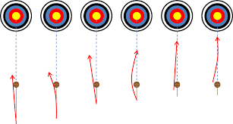
Figure 10 An arrow when released is subject to a high axial force and it will bend. But if the natural frequency is just right then the vibrating arrow will clear the bow and will go straight.

OUP – Diagram taken from here: https://en.arco-vienna.at/archers-paradox.html

References:
1) Engineering Materials I. D R H Jones, Michael F. Ashby, Elsevier, 19 Oct 2011
2) Physics of Bows and Arrows. P.E.Klopsteg Am J. of Physics,11 4 175-191 1943
3) On the Mechanics of the Bow and Arrow’ B.W. Kooi ‘, Thesis, 1983, Rijksuniversiteit te Groningen.

